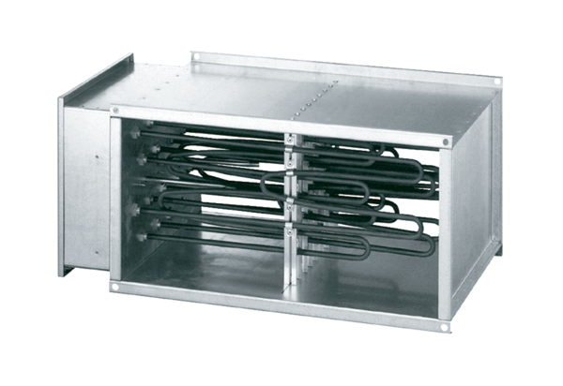Electrical air heater DHP 28-28Packing unit: 1 pieceRange: D
Article number: 0082.0095Manufacturer: MAICO

