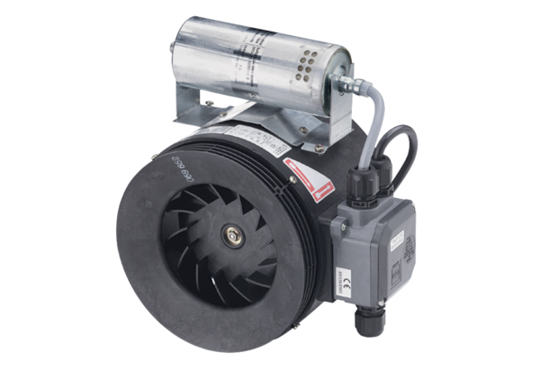Semi-centrifugal duct fan ERM 22 Ex e/60 HzPacking unit: 1 pieceRange: C
Article number: 0080.0374Manufacturer: MAICO

