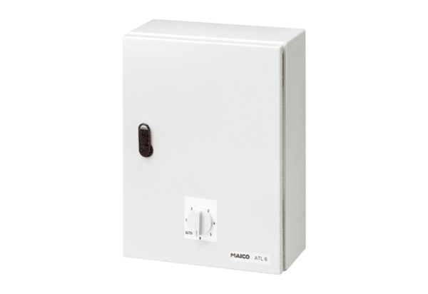Temperature control system, power module ATL 6Packing unit: 1 pieceRange: C
Article number: 0157.0758Manufacturer: MAICO

