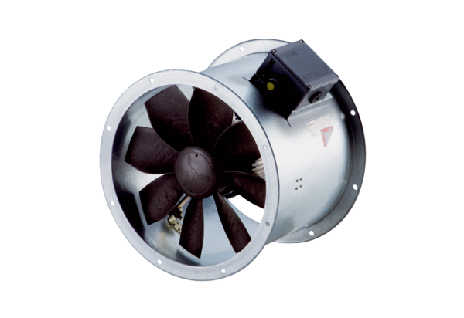Axial duct fan DZR 25/4 B Ex ePacking unit: 1 pieceRange: C
Article number: 0086.0701Manufacturer: MAICO

