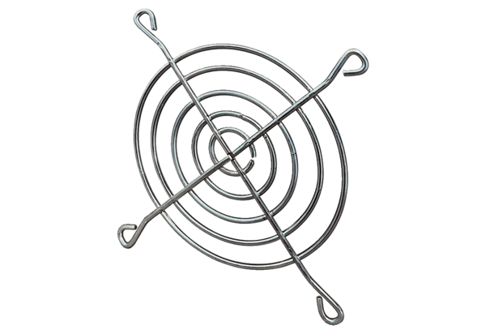Air outlet grille SGAI 14Packing unit: 1 pieceRange: C
Article number: 0073.0290Manufacturer: MAICO

