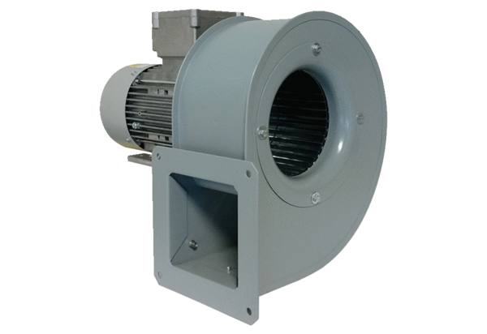Centrifugal blower GRM 18/2 D ExPacking unit: 1 pieceRange: C
Article number: 0073.0390Manufacturer: MAICO

