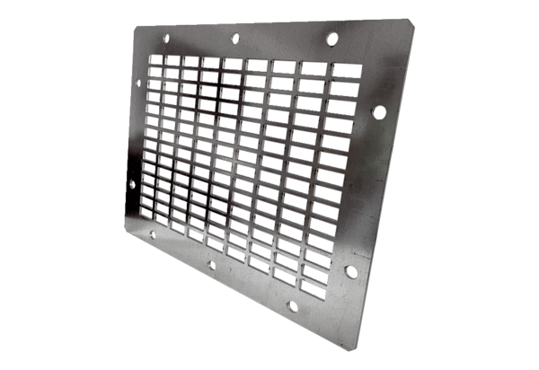Air outlet grille SGAI GR 20Packing unit: 1 pieceRange: C
Article number: 0073.0425Manufacturer: MAICO

