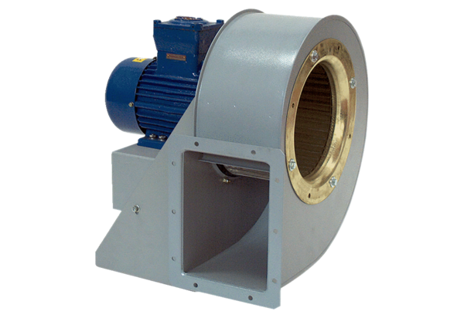Centrifugal blower GRM HD 28/4-1 ExPacking unit: 1 pieceRange: C
Article number: 0073.0403Manufacturer: MAICO

