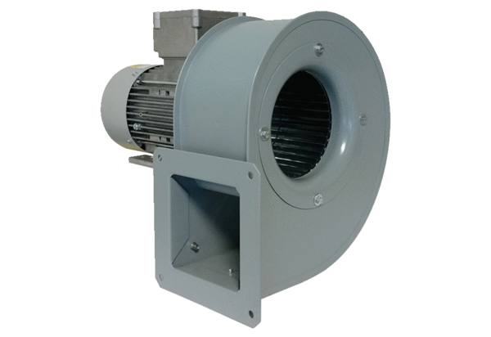Centrifugal blower GRM 12/2 E ExPacking unit: 1 pieceRange: C
Article number: 0073.0384Manufacturer: MAICO

