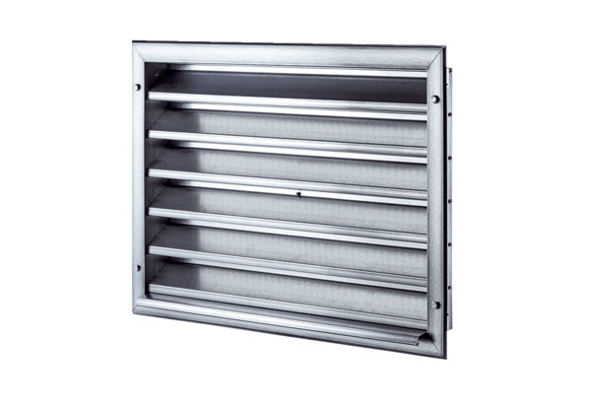External grille LZP 50Packing unit: 1 pieceRange: D
Article number: 0151.0314Manufacturer: MAICO

