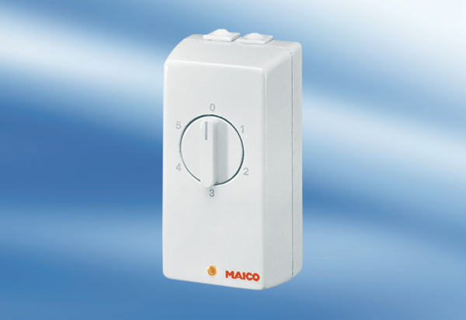TRE 1,6Packing unit: 1 pieceRange: C
Article number: 0016.0112Manufacturer: MAICO

