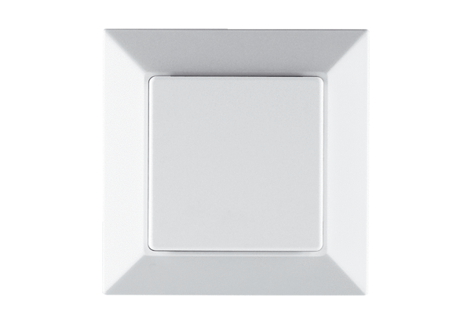Power module PP 45 LTPacking unit: 1 pieceRange: K
Article number: 0157.0361Manufacturer: MAICO

