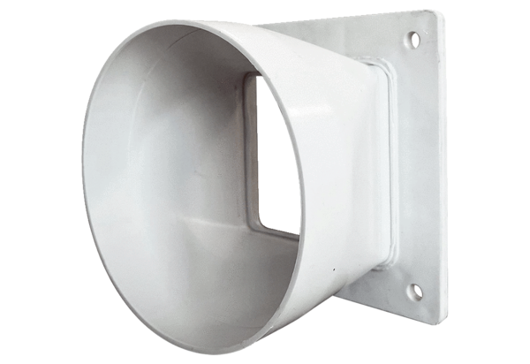Transition adapter URRI GR 12Packing unit: 1 pieceRange: C
Article number: 0073.0310Manufacturer: MAICO

