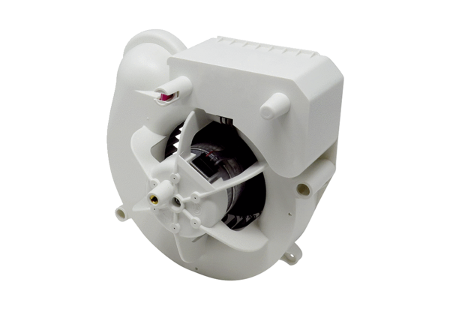Fan insert VE ER-APB 100 HRange: B
Article number: E084.0180.0000Manufacturer: MAICO

