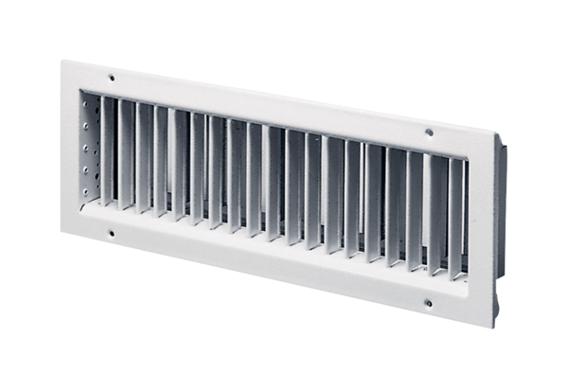Internal grille LGZ 62/12Packing unit: 1 pieceRange: D
Article number: 0151.0264Manufacturer: MAICO

