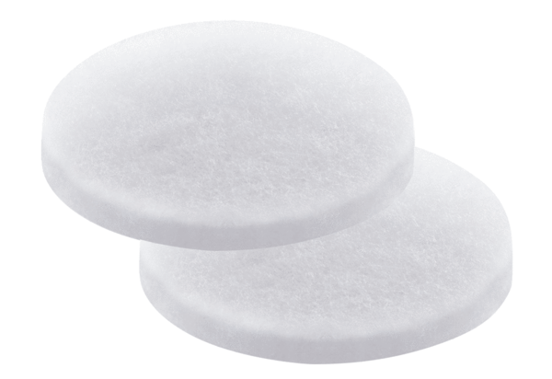Air filter, replacement PP 45 G3Packing unit: 2 piecesRange: K
Article number: 0093.0274Manufacturer: MAICO

