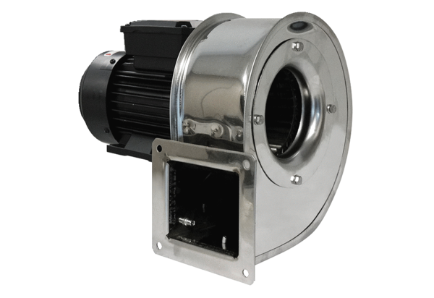Centrifugal blower GRM ES 10/2 DPacking unit: 1 pieceRange: C
Article number: 0073.0320Manufacturer: MAICO

