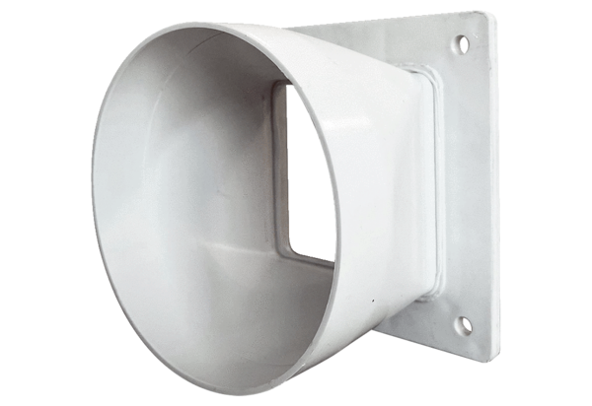Transition adapter URRI GR 16Packing unit: 1 pieceRange: C
Article number: 0073.0311Manufacturer: MAICO

