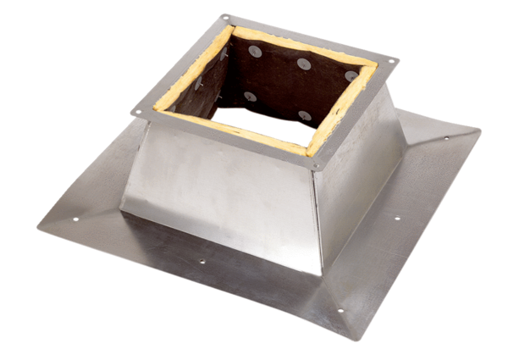Roof socket for flat roofs SO 18Packing unit: 1 pieceRange: C
Article number: 0093.0887Manufacturer: MAICO

