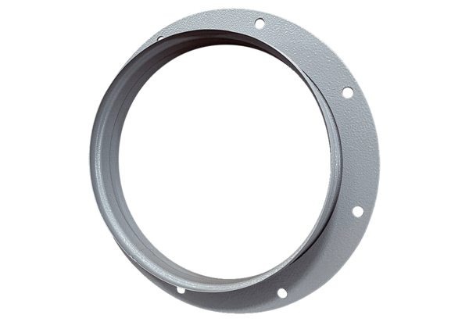Intake socket ASI 25Packing unit: 1 pieceRange: C
Article number: 0073.0435Manufacturer: MAICO

