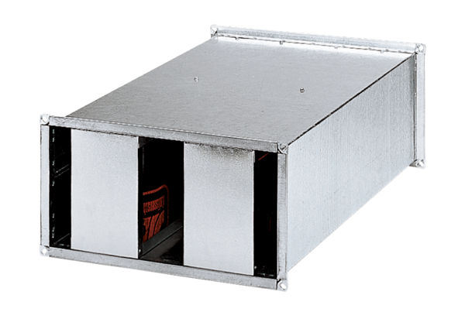Channel sound absorber KSP 28/23Packing unit: 1 pieceRange: D
Article number: 0092.0332Manufacturer: MAICO

