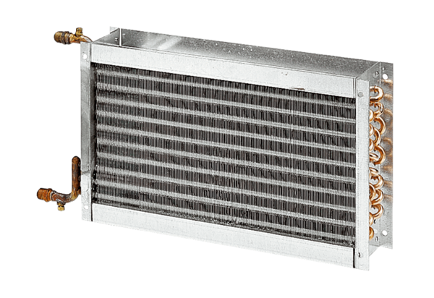Water air heater WHP 50-55Packing unit: 1 pieceRange: D
Article number: 0082.0123Manufacturer: MAICO

