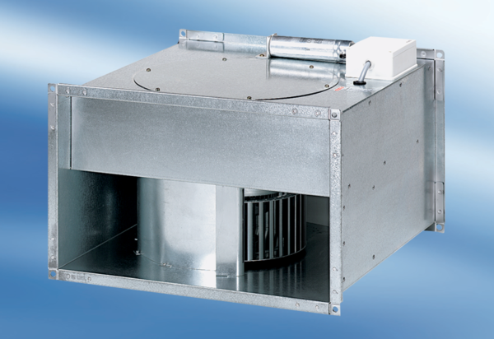Channel fan DPK 35/4Packing unit: 1 pieceRange: D
Article number: 0086.0639Manufacturer: MAICO

