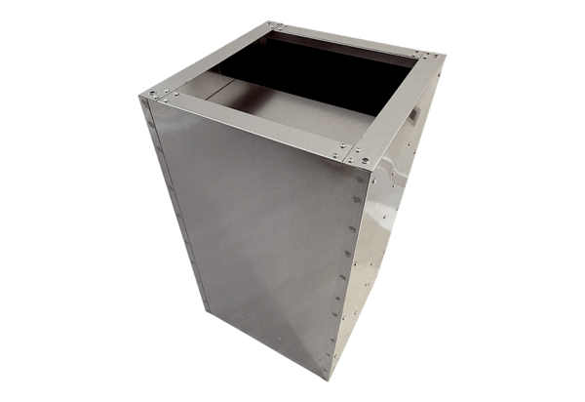Socket sound absorber SDVI 50-56Packing unit: 1 pieceRange: C
Article number: 0073.0038Manufacturer: MAICO

