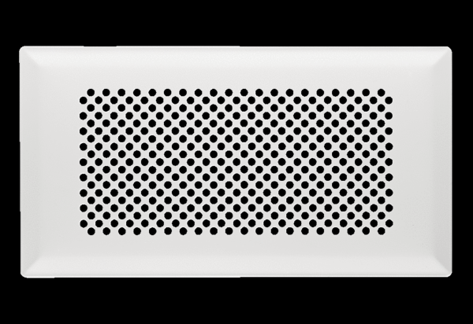Floor grille FFS-FGBWPacking unit: 1 pieceRange: K
Article number: 0055.0891Manufacturer: MAICO

