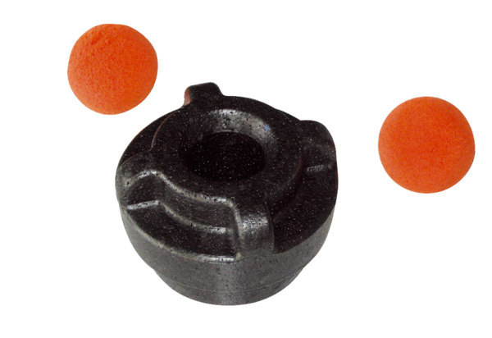Cleaning kit MF-R90Packing unit: 1 pieceRange: K
Article number: 0058.0013Manufacturer: MAICO

