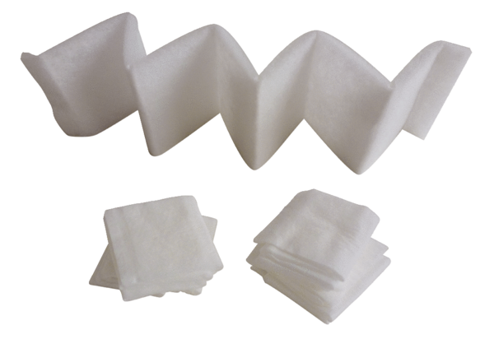Air filter, replacement FF 100Packing unit: 5 piecesRange: D
Article number: 0093.0652Manufacturer: MAICO

