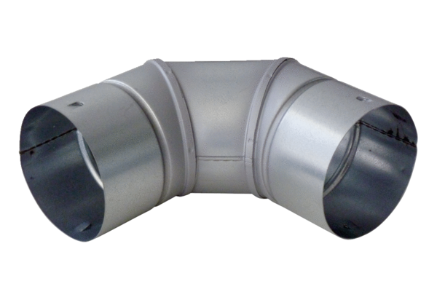90° sheet metal elbow MF-B90Packing unit: 1 pieceRange: K
Article number: 0018.0055Manufacturer: MAICO

