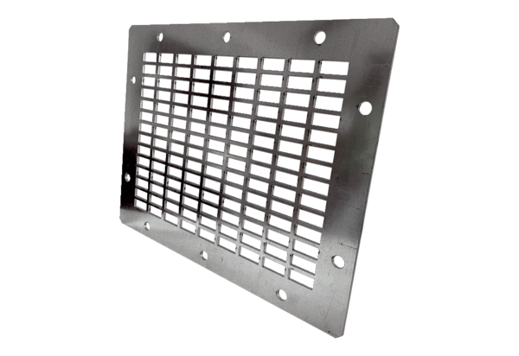Air outlet grille SGAI GR 40Packing unit: 1 pieceRange: C
Article number: 0073.0431Manufacturer: MAICO

