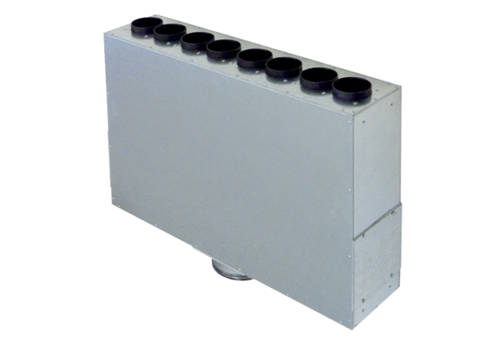Air distributor box made of sheet metal, 8-way MF-BV63-125-8Packing unit: 1 pieceRange: K
Article number: 0018.0525Manufacturer: MAICO

