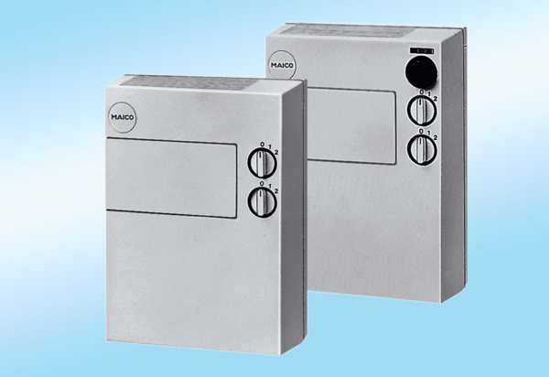Fresh air unit POL 100 ZPacking unit: 1 pieceRange:
Article number: 0082.0054Manufacturer: MAICO

