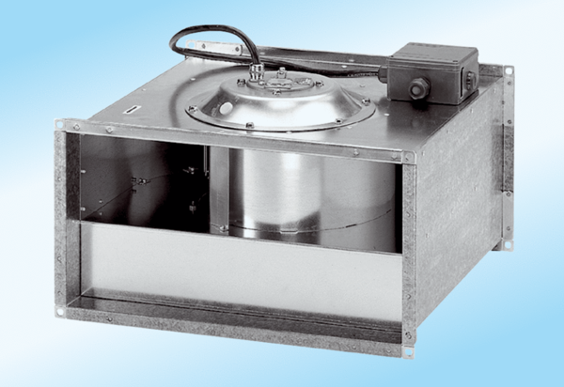Channel fan DPK 25/4 ExPacking unit: 1 pieceRange: D
Article number: 0086.0641Manufacturer: MAICO

