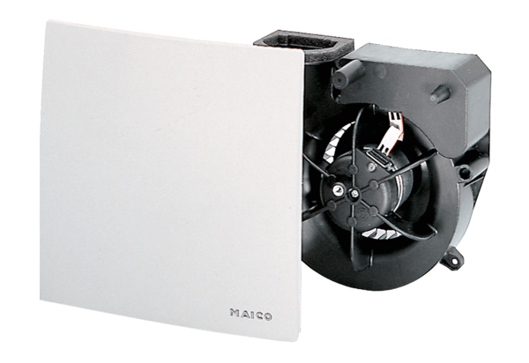Fan insert ER 100Packing unit: 1 pieceRange: B
Article number: 0084.0130Manufacturer: MAICO

