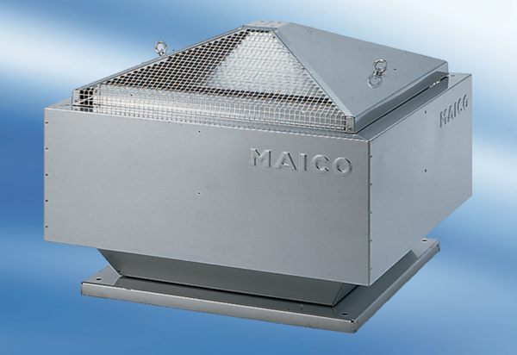Centrifugal roof fan DRD 50/86Packing unit: 1 pieceRange: C
Article number: 0087.0157Manufacturer: MAICO

