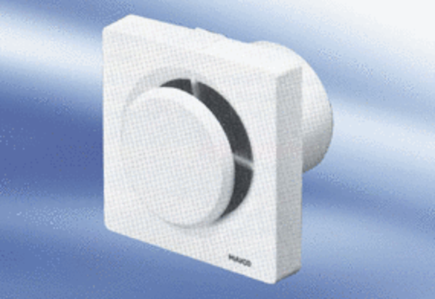Small room fan ECA 11Packing unit: 1 pieceRange:
Article number: 080401Manufacturer: MAICO

