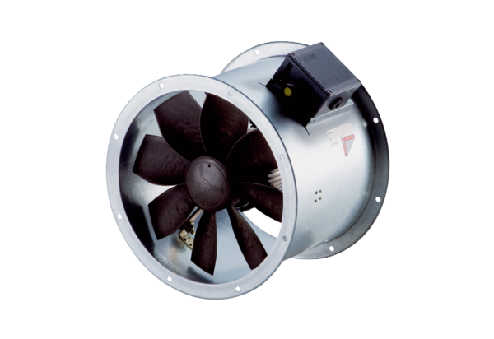Axial duct fan DZR 50/4 B Ex ePacking unit: 1 pieceRange: C
Article number: 0086.0714Manufacturer: MAICO

