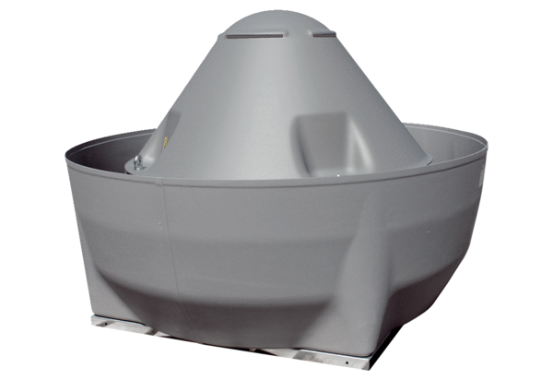Centrifugal roof fan DRD V 56/6 ExPacking unit: 1 pieceRange: C
Article number: 0073.0551Manufacturer: MAICO

