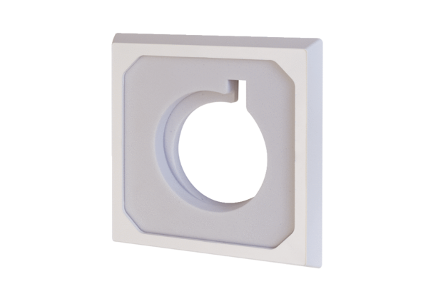Sound-absorbing element set ER-SE ECPacking unit: 1 pieceRange: B
Article number: 0093.1565Manufacturer: MAICO

