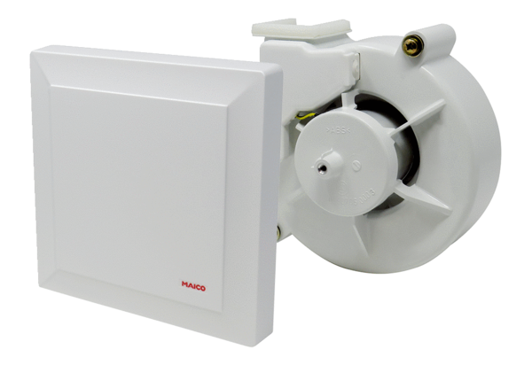Fan insert with cover VEA ER 17/100Range: B
Article number: E080.0739.0000Manufacturer: MAICO

