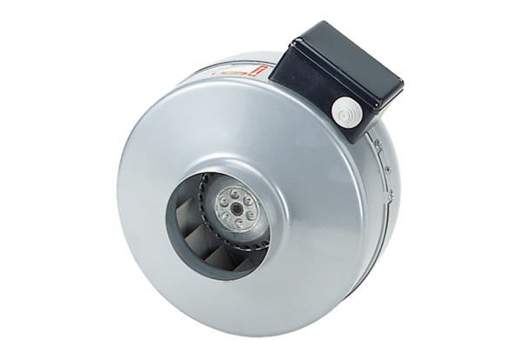Centrifugal duct fan ERR 20/1 ECPacking unit: 1 pieceRange: E
Article number: 0073.0570Manufacturer: MAICO

