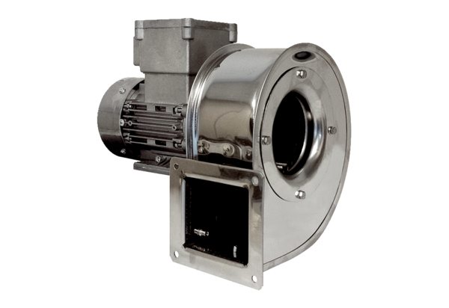Centrifugal blower GRM ES 14/2 ExPacking unit: 1 pieceRange: C
Article number: 0073.0393Manufacturer: MAICO

