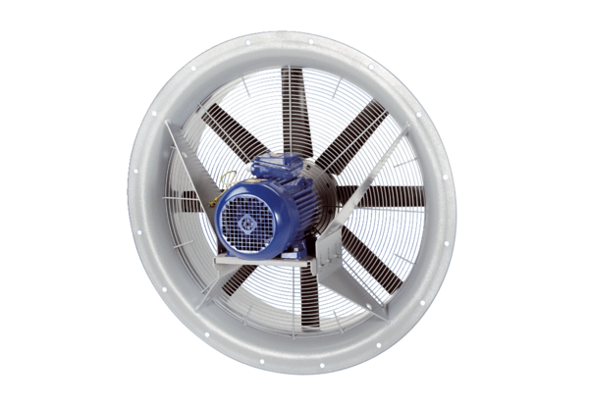Axial fan DAS 90/8Packing unit: 1 pieceRange: C
Article number: 0083.0857Manufacturer: MAICO

