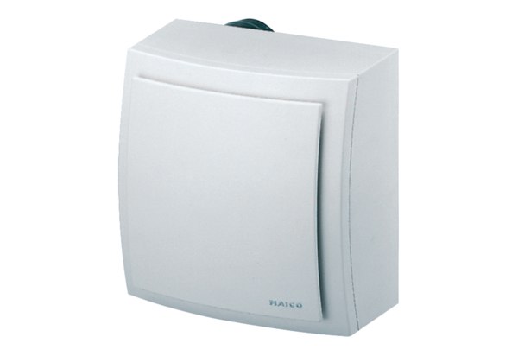Surface-mounted fan, fire protection ER-APB 100Packing unit: 1 pieceRange: B
Article number: 0084.0176Manufacturer: MAICO

