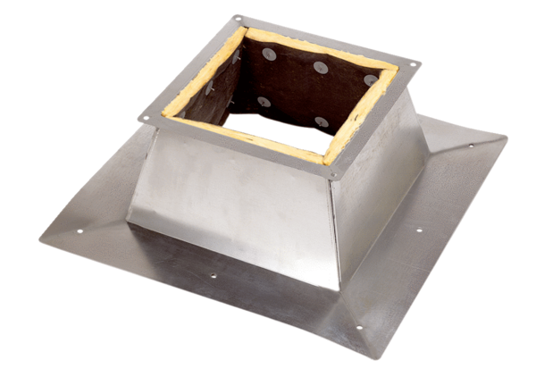Roof socket for flat roofs SO 35Packing unit: 1 pieceRange: C
Article number: 0093.0362Manufacturer: MAICO

