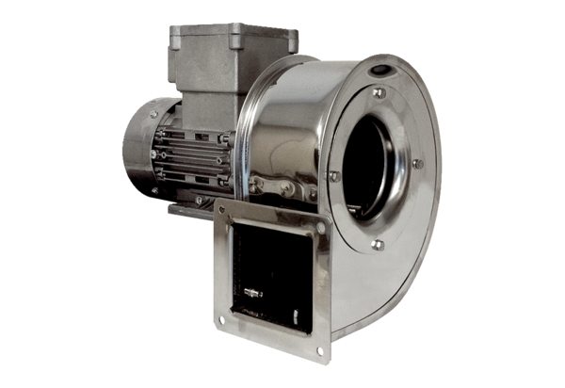Centrifugal blower GRM ES 16/2 ExPacking unit: 1 pieceRange: C
Article number: 0073.0394Manufacturer: MAICO

