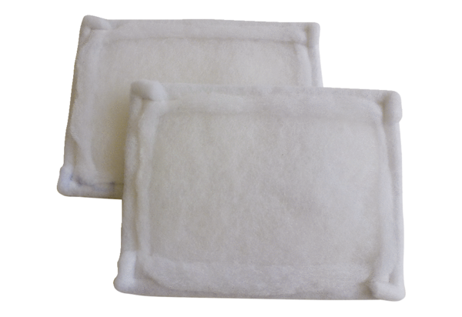Air filter, replacement FE 12-1Packing unit: 2 piecesRange: C
Article number: 0093.1222Manufacturer: MAICO

