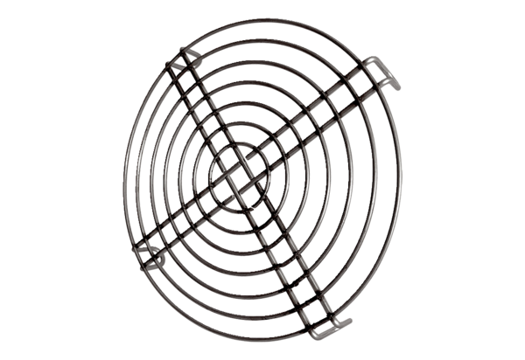Inlet protective grille SGEI K 25Packing unit: 1 pieceRange: C
Article number: 0073.0463Manufacturer: MAICO

