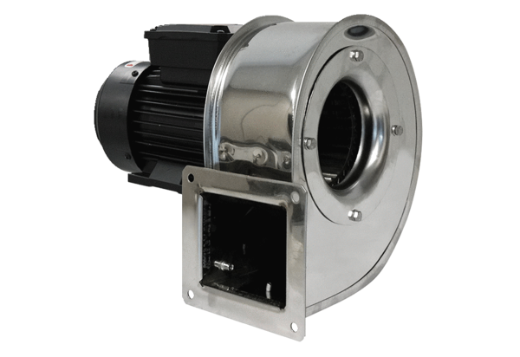Centrifugal blower GRM ES 10/2 EPacking unit: 1 pieceRange: C
Article number: 0073.0316Manufacturer: MAICO

