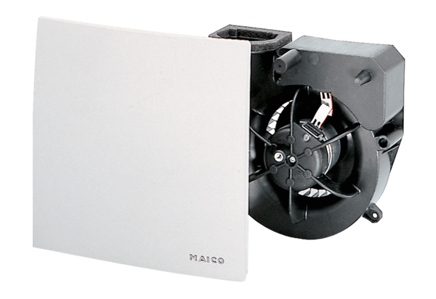Fan insert ER 60 IPacking unit: 1 pieceRange: B
Article number: 0084.0105Manufacturer: MAICO

