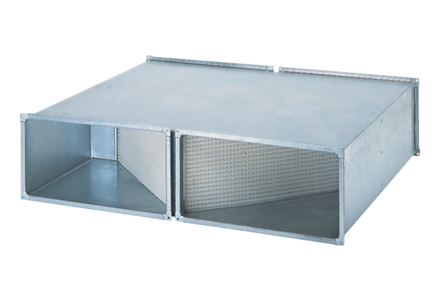Heat exchanger WT 750Packing unit: 1 pieceRange: D
Article number: 0152.0041Manufacturer: MAICO

